PUTNAM VALLEY TOWN BOARD
TOWN BOARD MEETING
7:00 P.M.
WEDNESDAY, NOVEMBER 18, 2015

1. Pledge of Allegiance
2. Supervisor’s Opening Comments
3. Special School District Vote Discussion-J. Figarella District Treasurer
4. Adopt 2016 Town/Highway/District Budget
5. Approval of Town Board Minutes
6. County Legislators Report
7. Accept 2016 CSEA Holiday Schedule
8. Authorize Glenmar Gardens Water Improvement Ban
Renewal
9. Schedule Public Hearing for Proposed Local Law-Rental Registration
10. Adopt Resolution to Partially Exempt Eligible Veterans Residing In
Cooperative Apartments from Local Town Taxation
11. Authorize Facilities Dept. to Advertise for Town Hall Maintenance Position

DEPARTMENTS
12. Parks & Recreation
a. Refunds
b. Personnel
c. Children’s Center Salaries
13. Building Department
a. Report for October 2015
14. Highway
a. Appoint Snow Plow Riders
15. DISTRICTS
a. Lake Peekskill
1. District Report
b. Wildwood Knolls
1. Accept Wildwood Knolls Revenue
16. Public Comment
17. Budget Transfers & Amendments
18. Audit of Monthly Bills\
19. Adjournment

PUTNAM VALLEY
TOWN BOARD MEETING
7:00 P.M.
WEDNESDAY, NOVEMBER 18, 2015

Present: Supervisor Tendy
Councilwoman Whetsel
Councilwoman Annabi
Councilman Mackay
Councilman Luongo

Also Present: Eileen Royael, Town Clerk
William Florence, Town Counsel

AMENDMENTS TO THE AGENDA

Presented by Supervisor Tendy

RESOLUTION #R 15-277

RESOLVED that the Town Board amend the agenda to add the following:

Add two Executive Sessions to discuss personnel, assessment litigation at beginning of meeting and contractual and personnel matter at end of meeting.

Add #2a-Certificate of Appreciation- Eagle Scout Noah Kelvas

#11a- Authorize Engineering Expenditure-Photovoltaic System

#11b- Authorize Facilities Dept. to Request Proposals for Architectural Plans -Town Hall Addition

#15C.1- Review and Award Bid- Spur Beach Slope Correction

Seconded by Councilman Mackay, unanimously carried.

Supervisor Tendy moved to go into Executive Session at 7:06 p.m. to discuss personnel and assessment litigation matters.

Seconded by Councilman Mackay, unanimously carried.

Meeting resumed at 7:31 p.m.

SUPERVISOR’S OPENING COMMENTS

Supervisor Tendy wished everyone a Happy Thanksgiving. He wanted the residents to all remember how blessed we are this Thanksgiving to live in our country that has been blessed with abundance of bounty.

Councilman Mackay told the residents that the Putnam County Coalition is doing a lot of good things in regard to alcohol and drug abuse. The night before Thanksgiving is called “Blackout Wednesday” it is a time that college students come home for the holiday, meet with their friends and there is a lot of drinking involved. The Putnam County law enforcement will be checking to make sure that bars are not serving underage students. If you are over 21, make sure you have a designated driver. Too many tragedies happen on this particular night.

CERTIFICATE OF APPRECIATION- EAGLE SCOUT NOAH KELVAS

Supervisor Tendy presented Eagle Scout Noah Kelvas with a Certificate of Appreciation from the Town of Putnam Valley for obtaining the rank of “Eagle Scout.”

SPECIAL SCHOOL DISTRICT VOTE DISCUSSION-J. FIGARELLA-DISTRICT TREASURER

Jill Figarella, District Treasurer for the Putnam Valley Central School District explained the special vote that is taking place on December 8th from 3:00-9:00 p.m. If this vote passes it will allow the district to establish a “Building Reserve Fund.” At the end of the year when there are monies left over, we can designate some of that money into this reserve fund. It will not cost the taxpayers anything, and it will save money as we will not have to borrow money to repair something. The district is not allowed to withdraw from the reserve fund without voter’s approval.

Supervisor Tendy feels this is a very good planning tool.

ADOPT 2016 TOWN/HIGHWAY/DISTRICT BUDGET

Presented by Supervisor Tendy

RESOLUTION #R15-278

RESOLVED that the Town Board adopt the 2016 Town/Highway and District Budget without the Fire Department SF01.3410.411, SF01.1001, SF9045.800, Putnam Valley Volunteer Ambulance Corps A.4540.400 and the Assessor’s Salary A.1355.110 and A.1001.
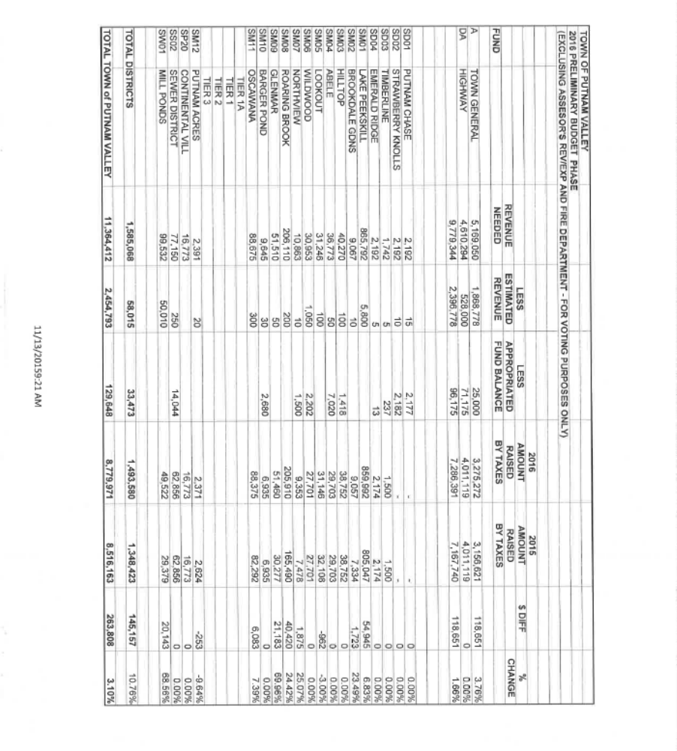
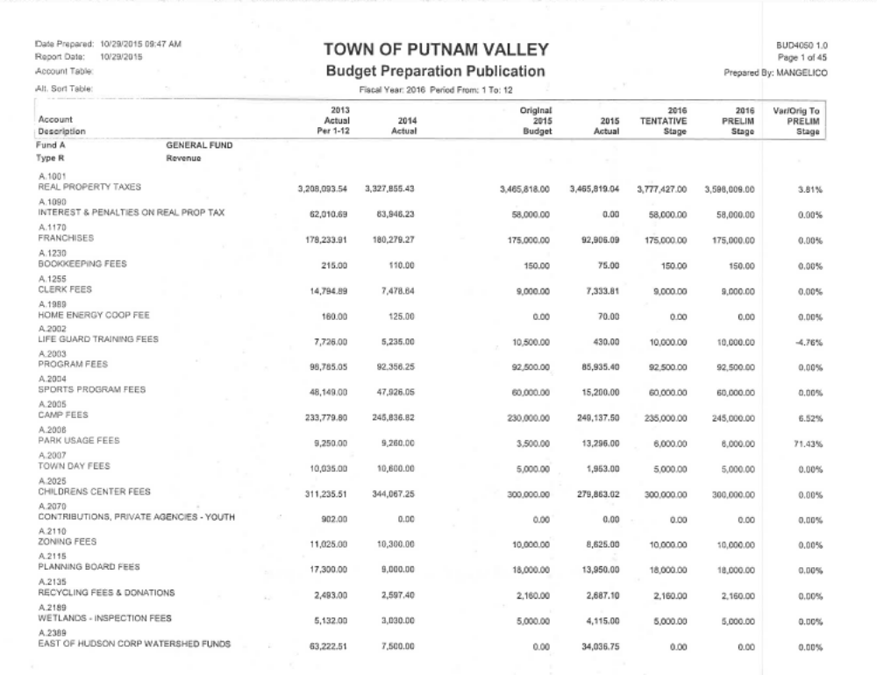
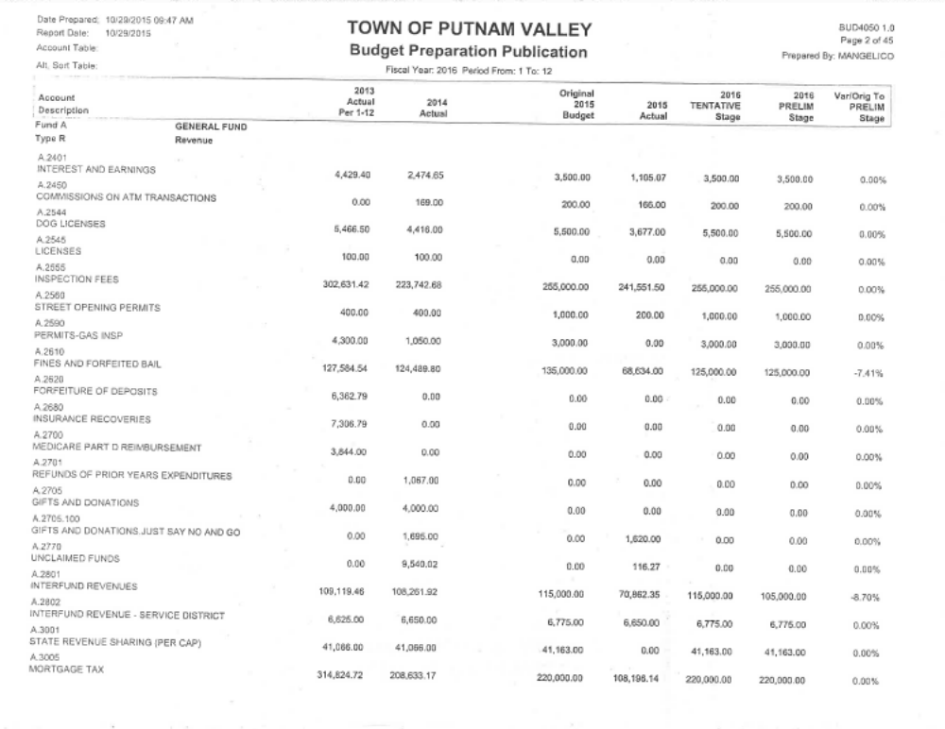

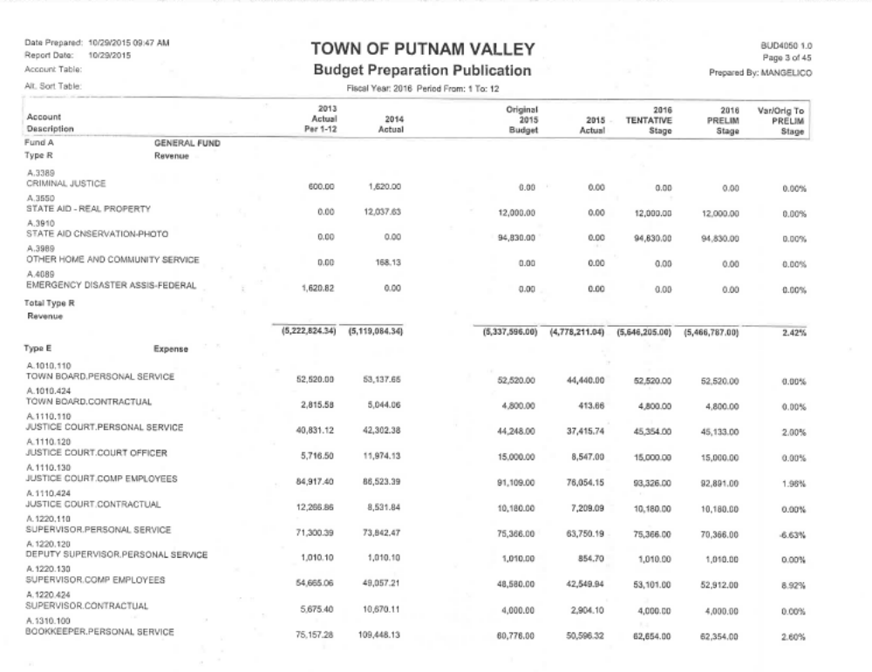
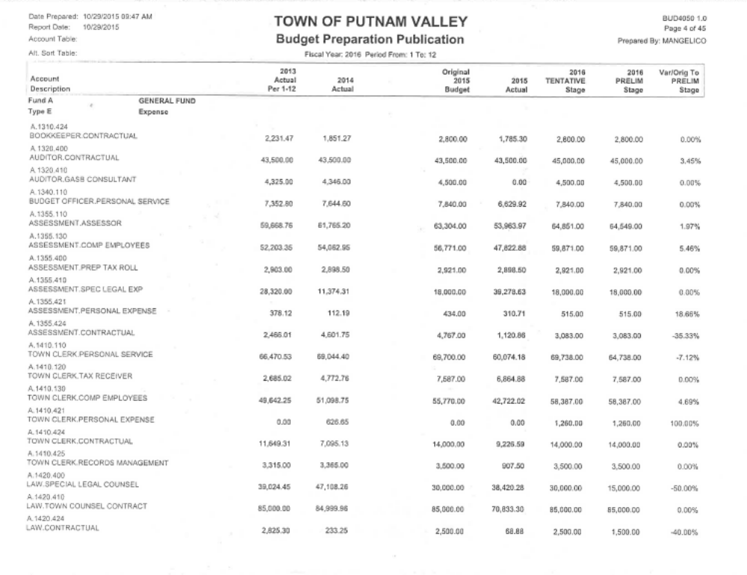
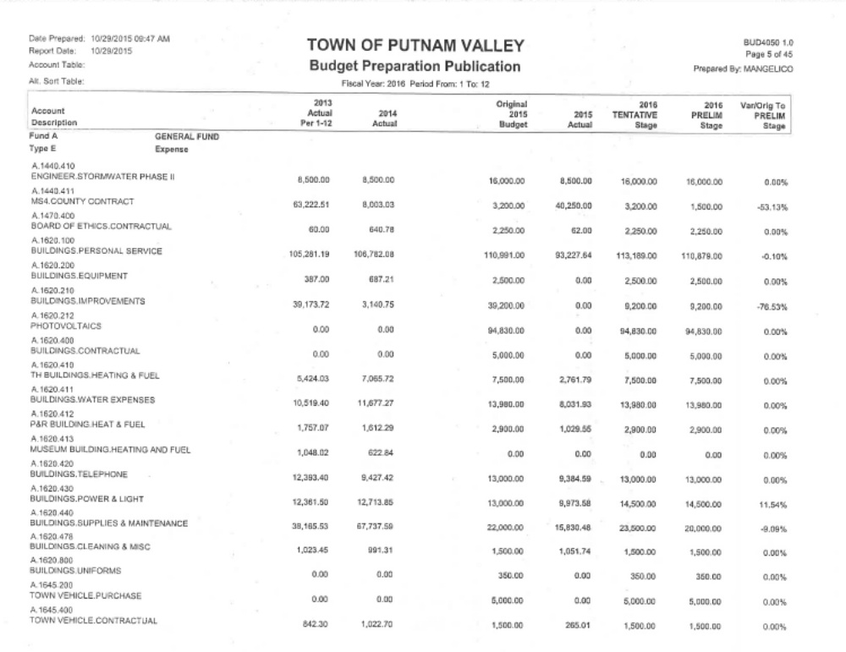
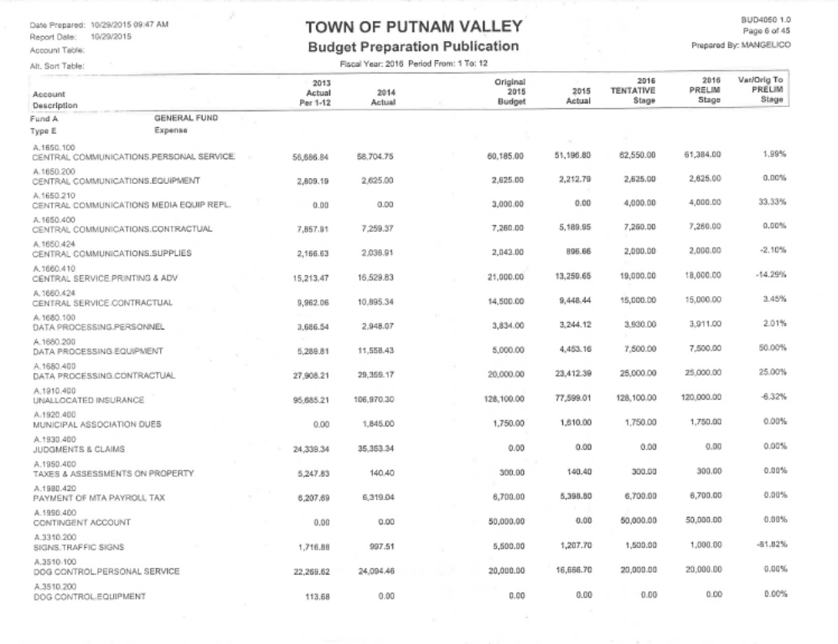
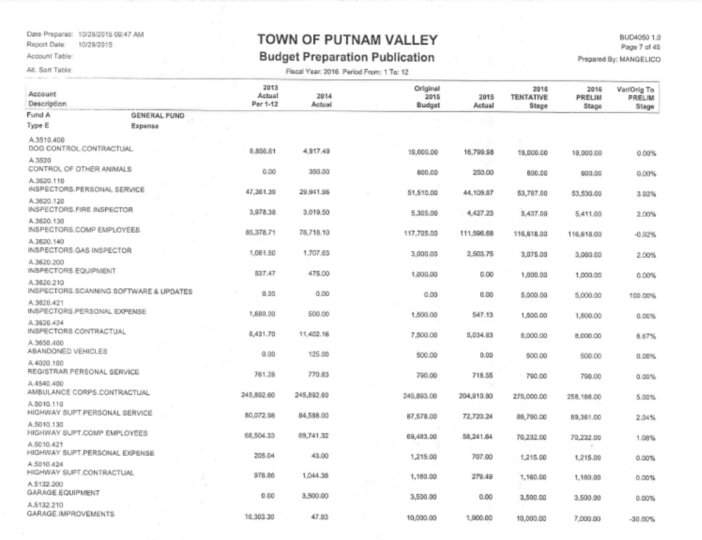
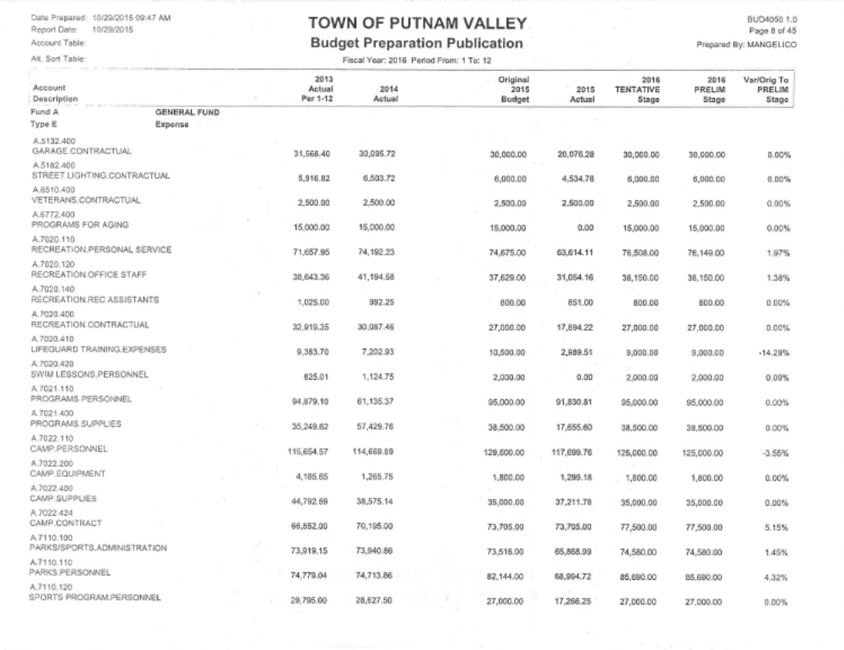
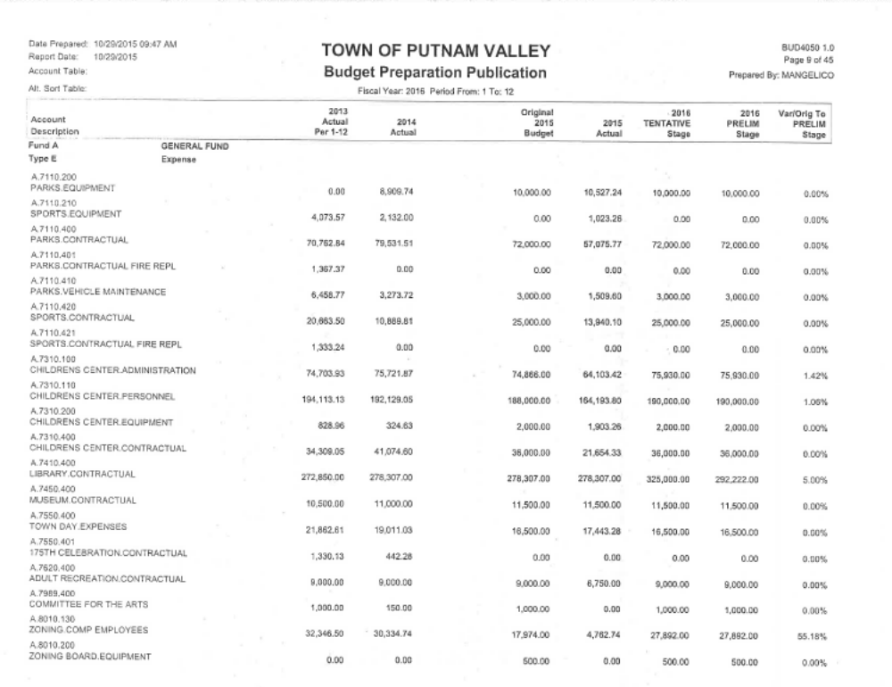
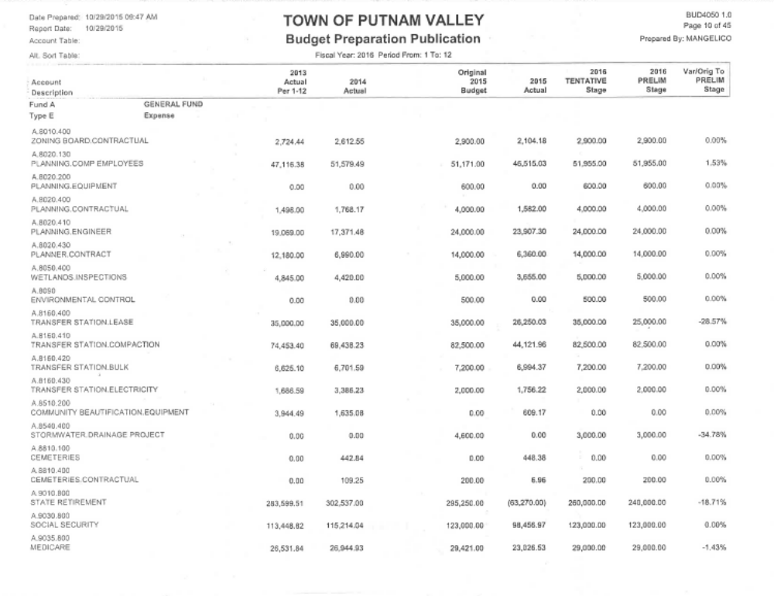

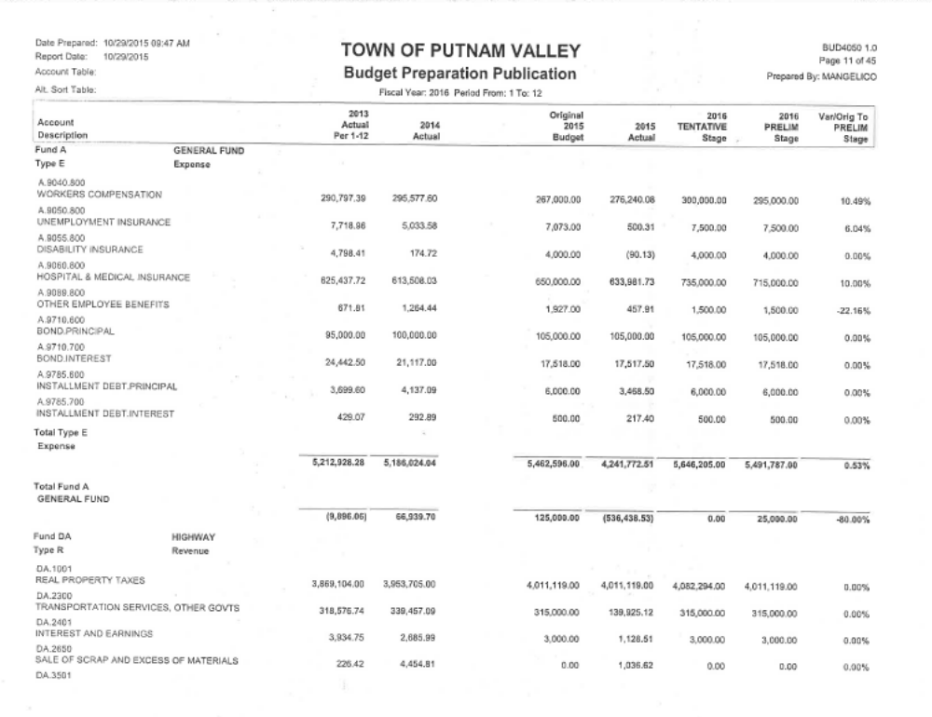
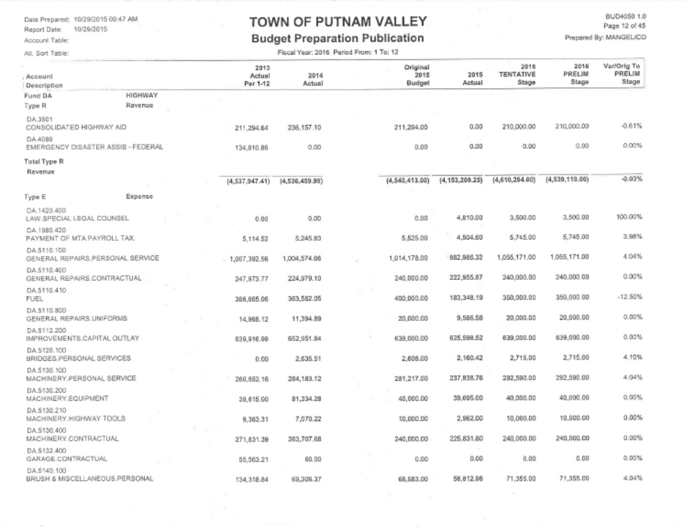
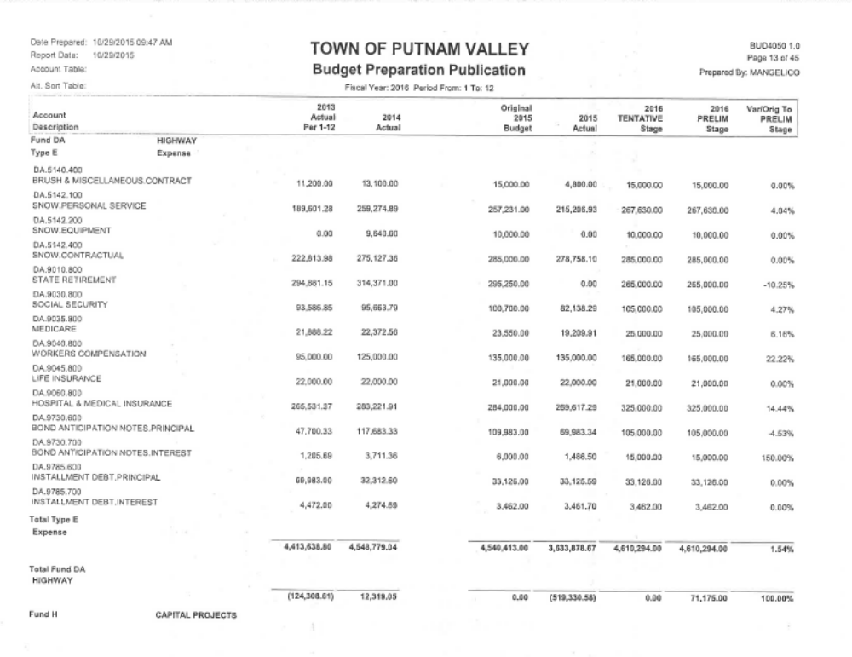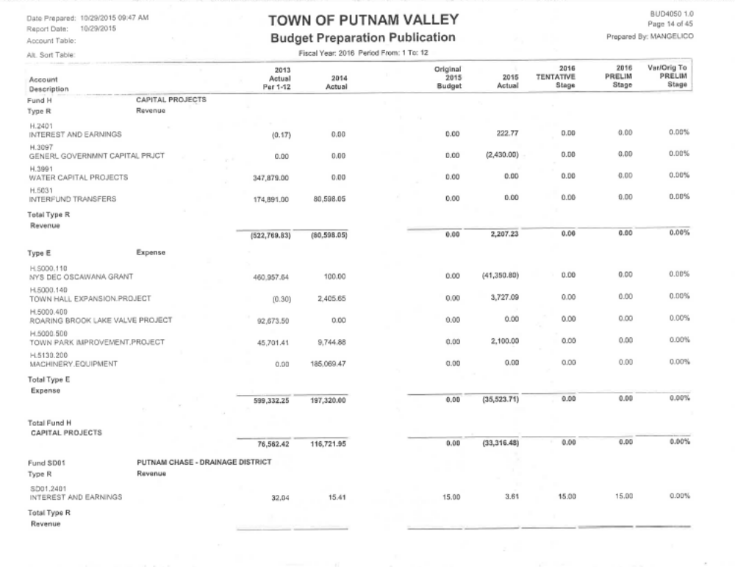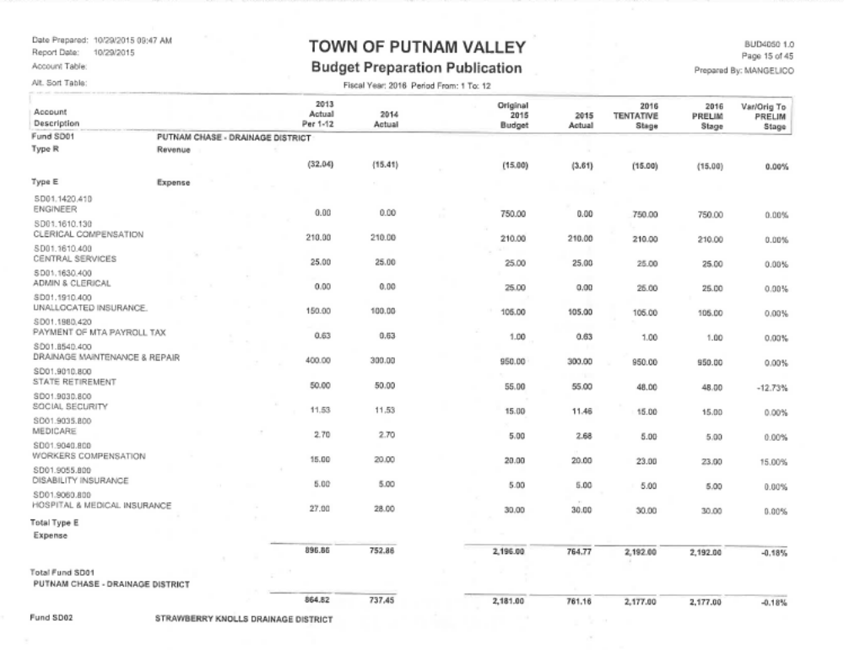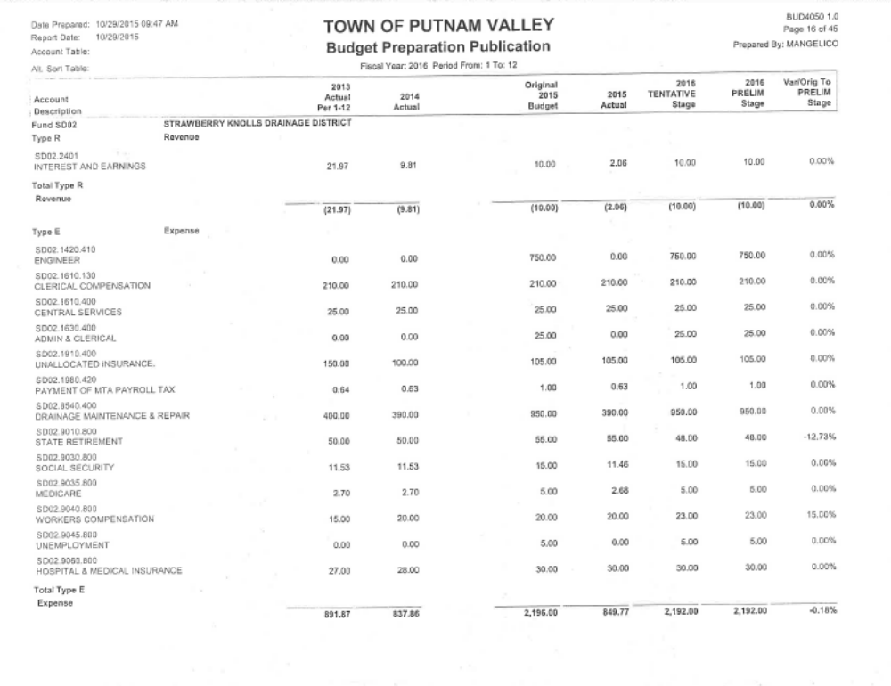
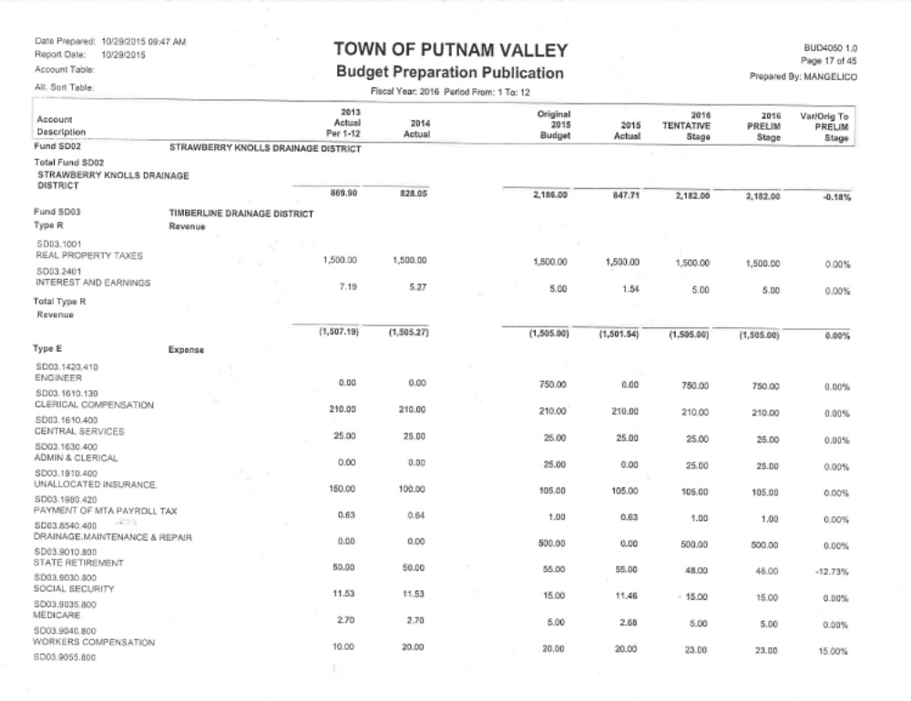
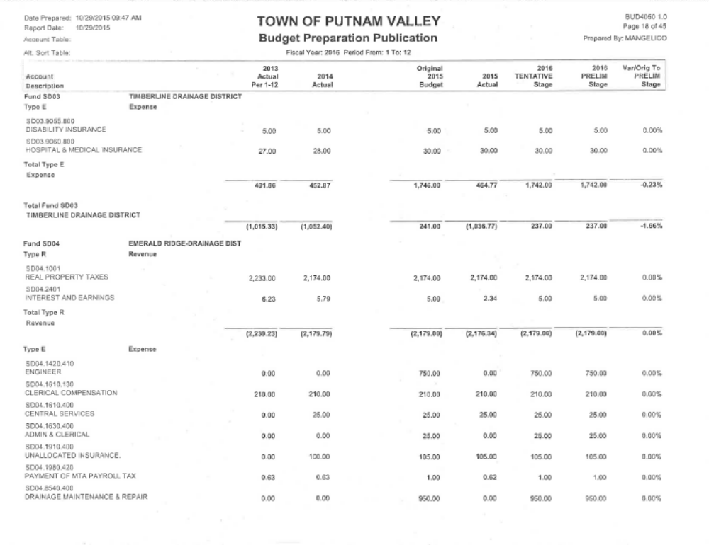
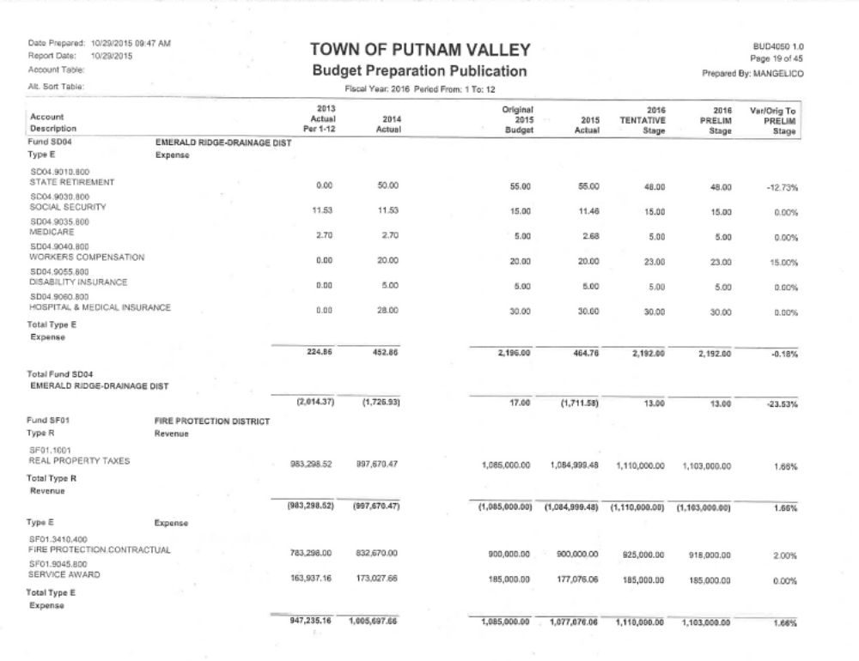
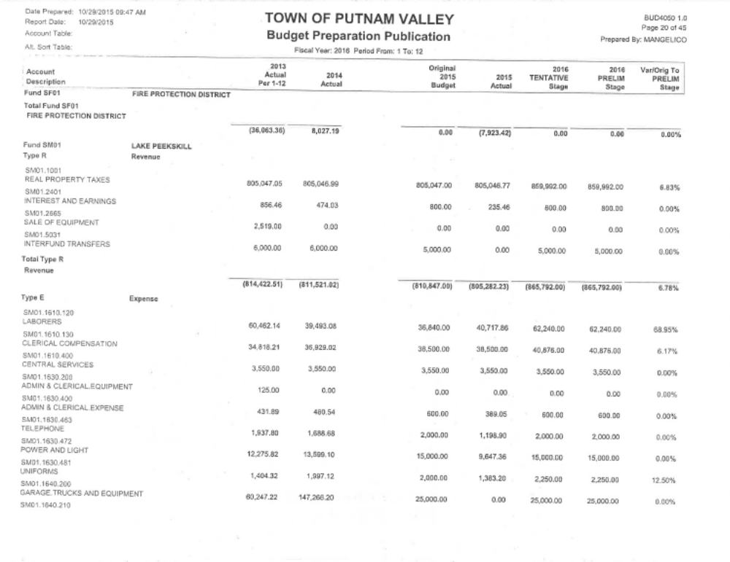
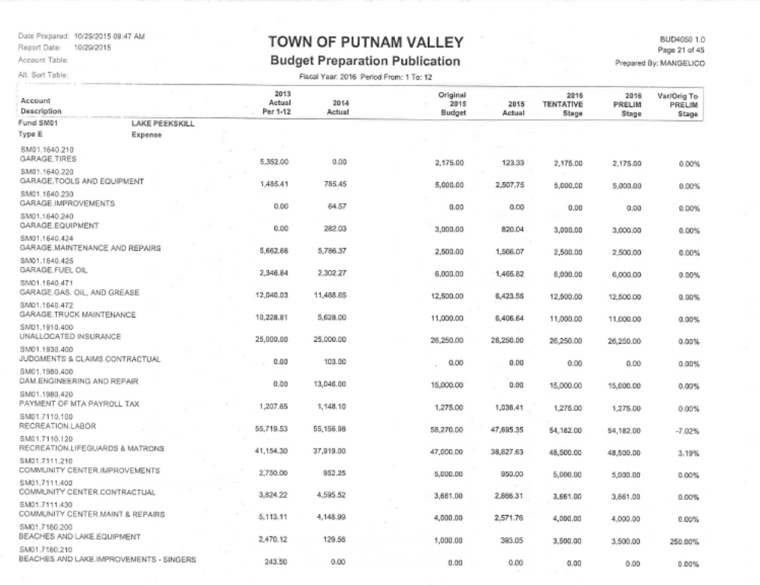
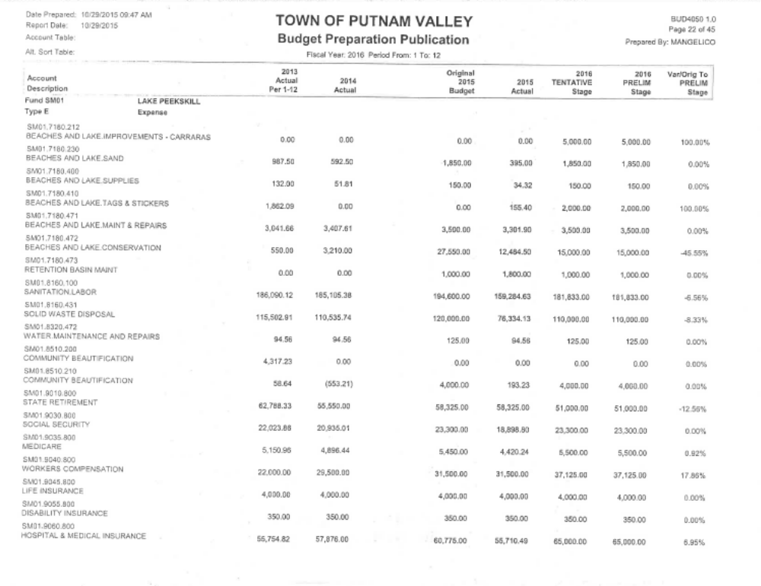
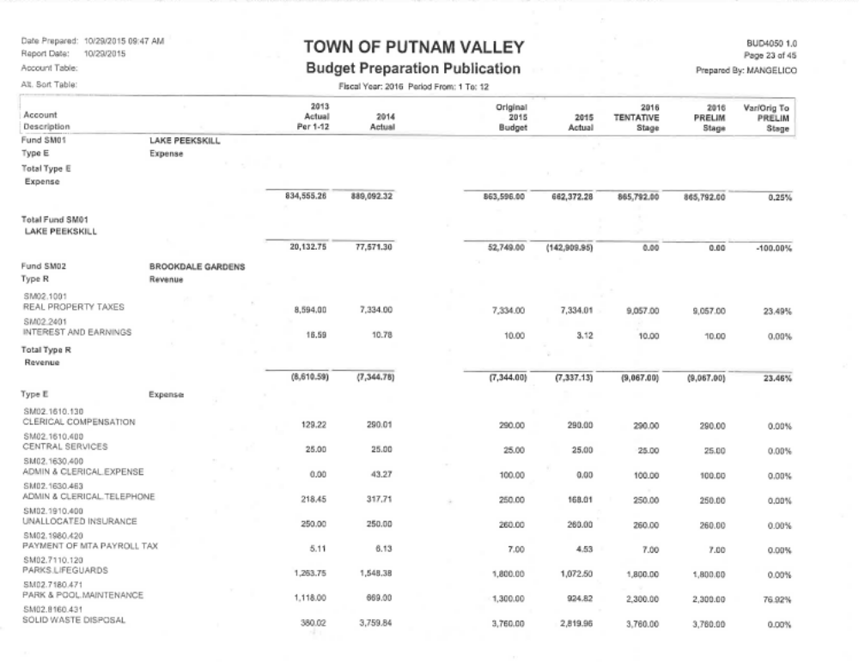
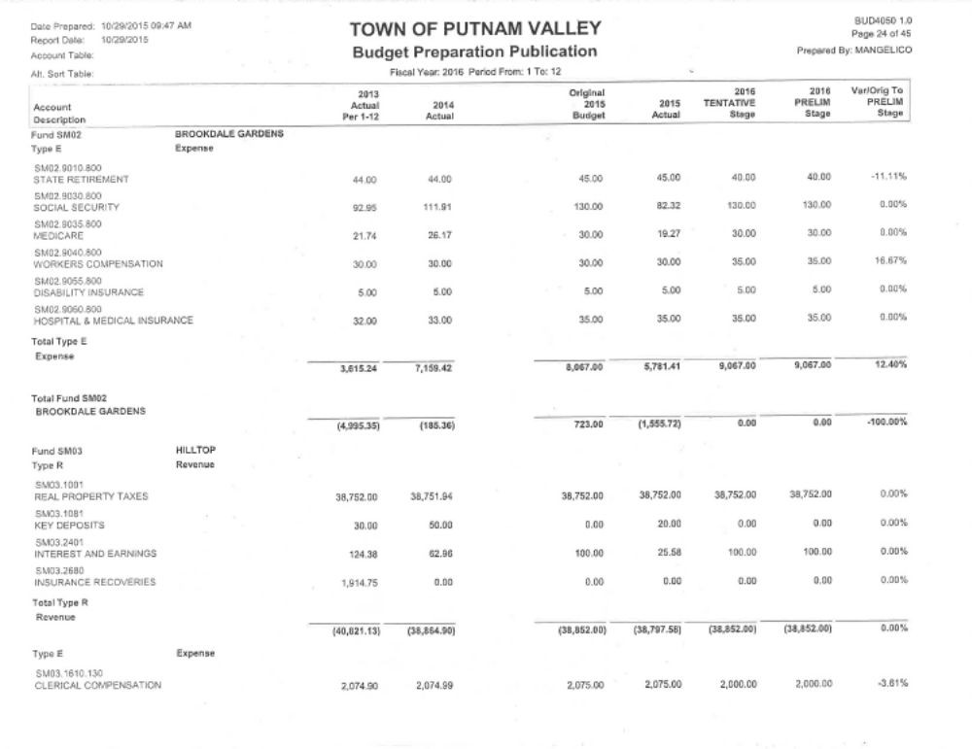
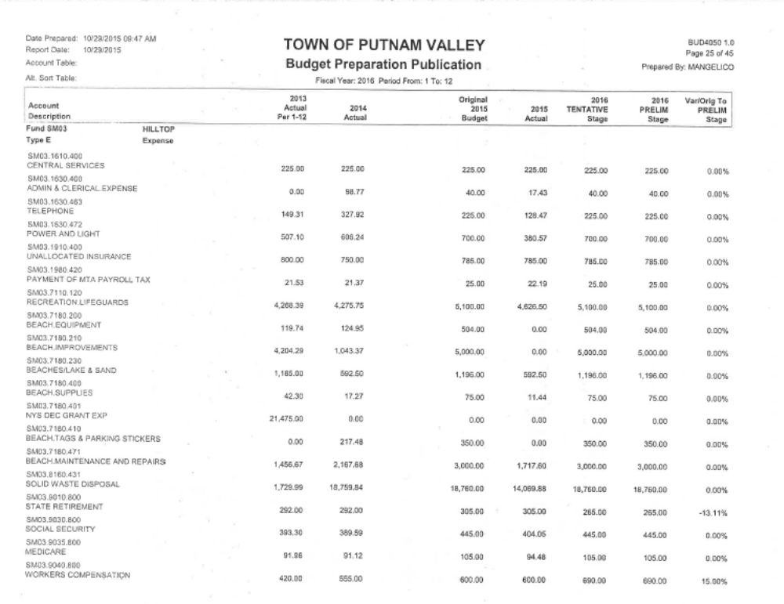
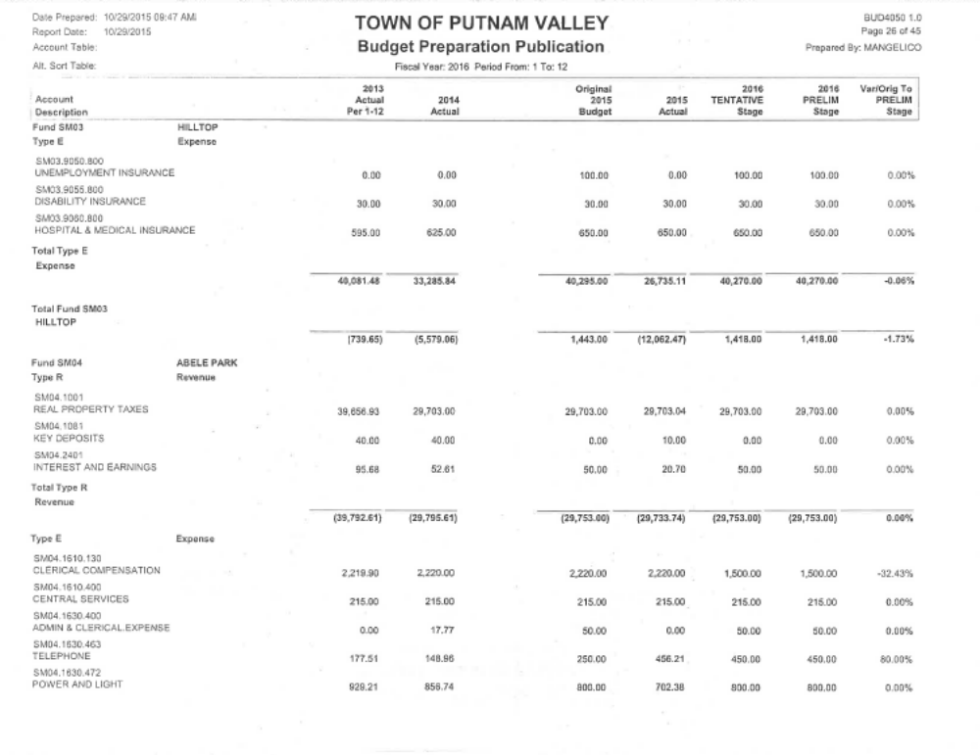
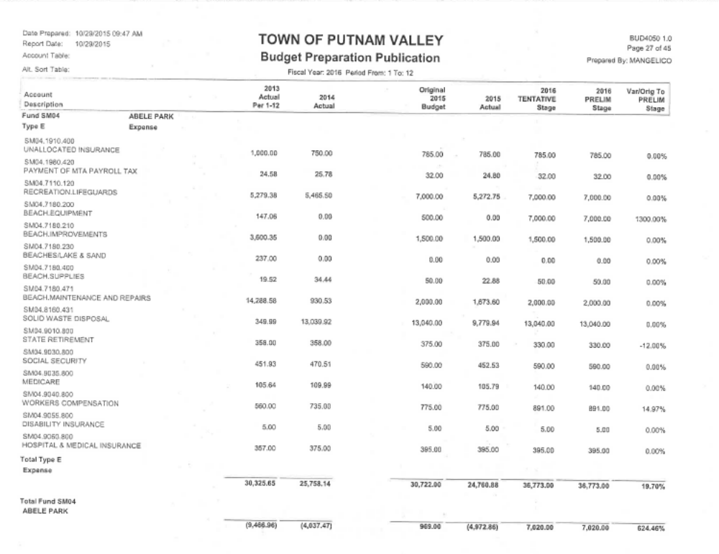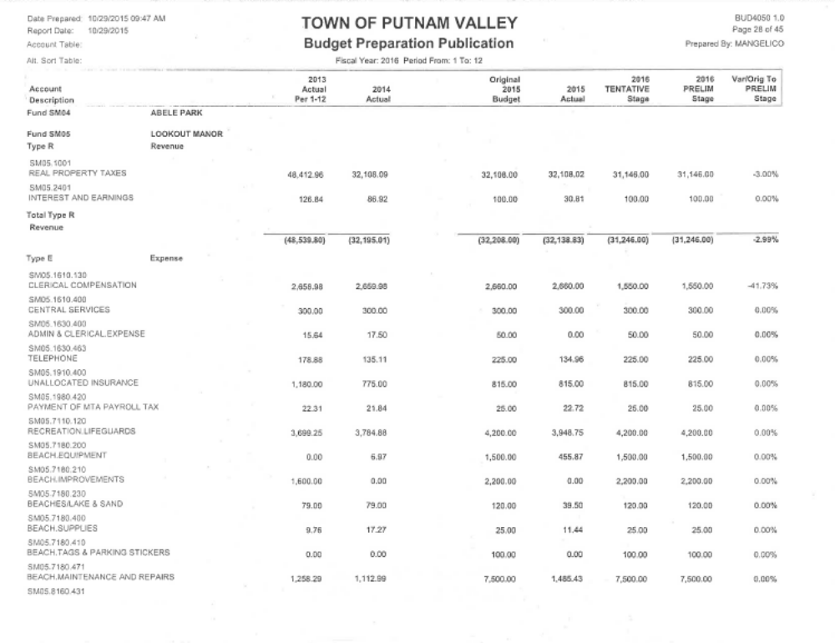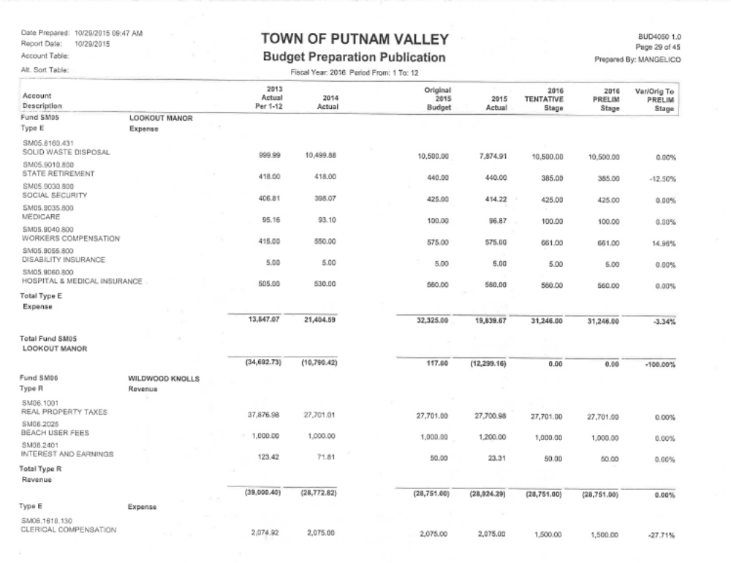
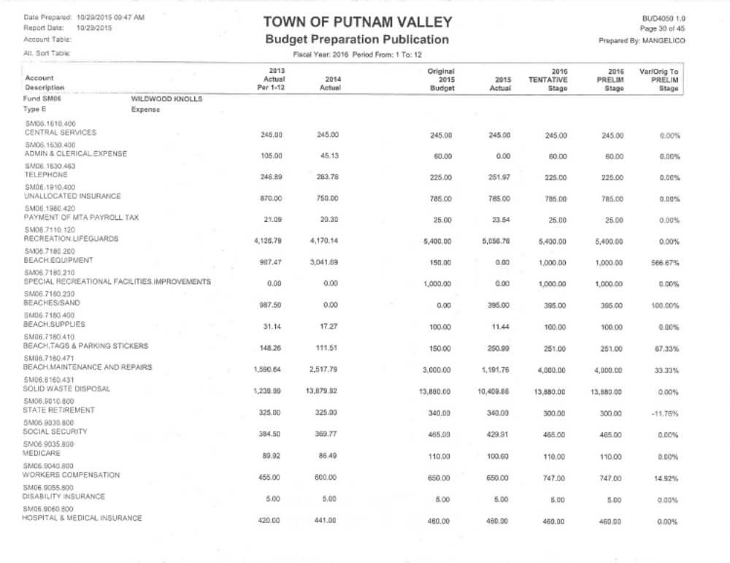
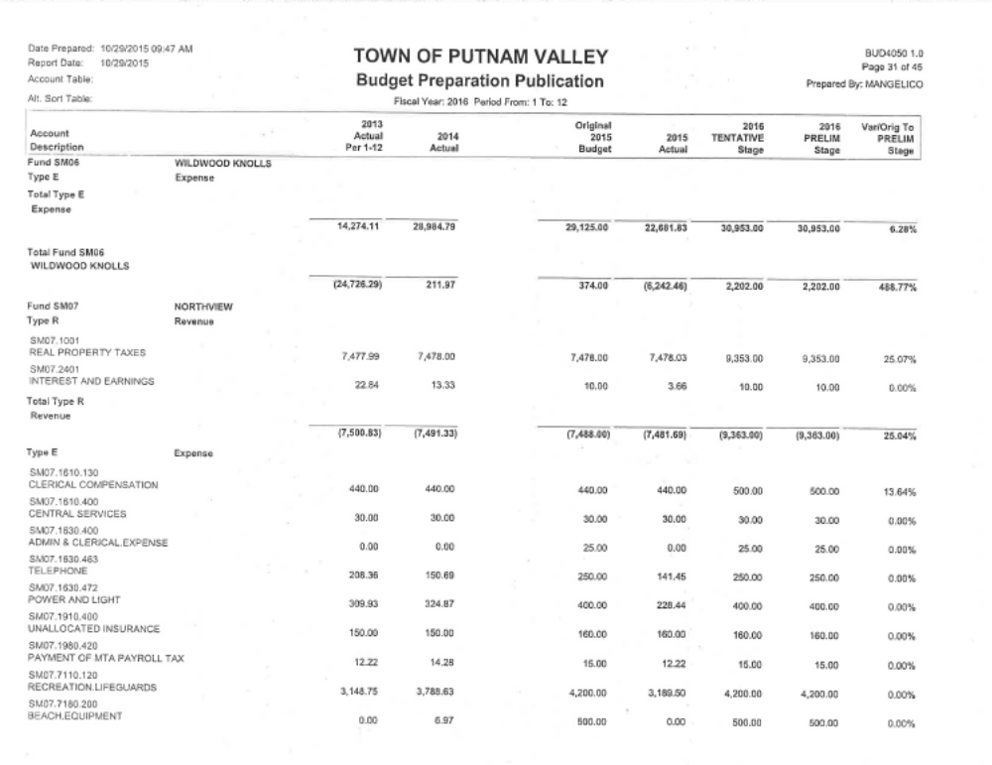
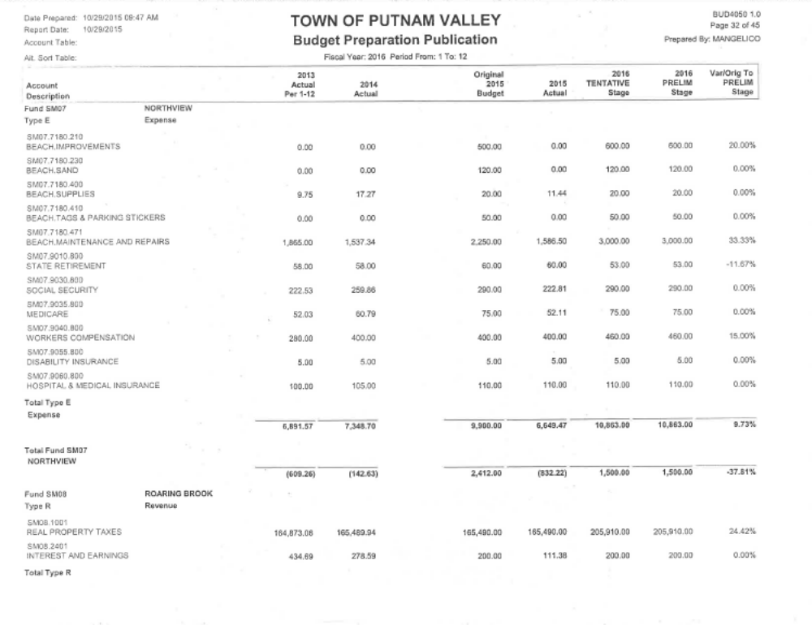
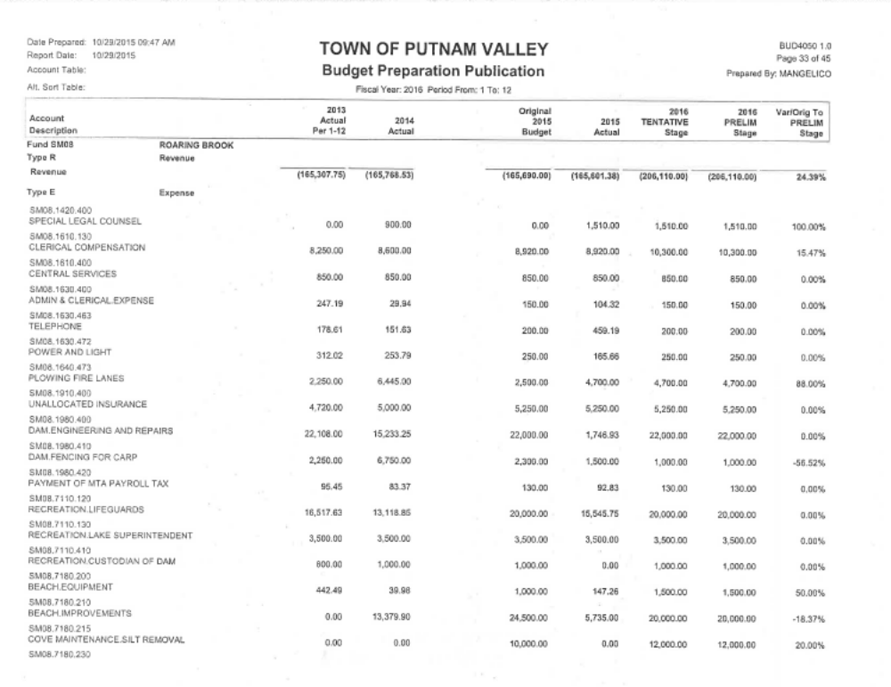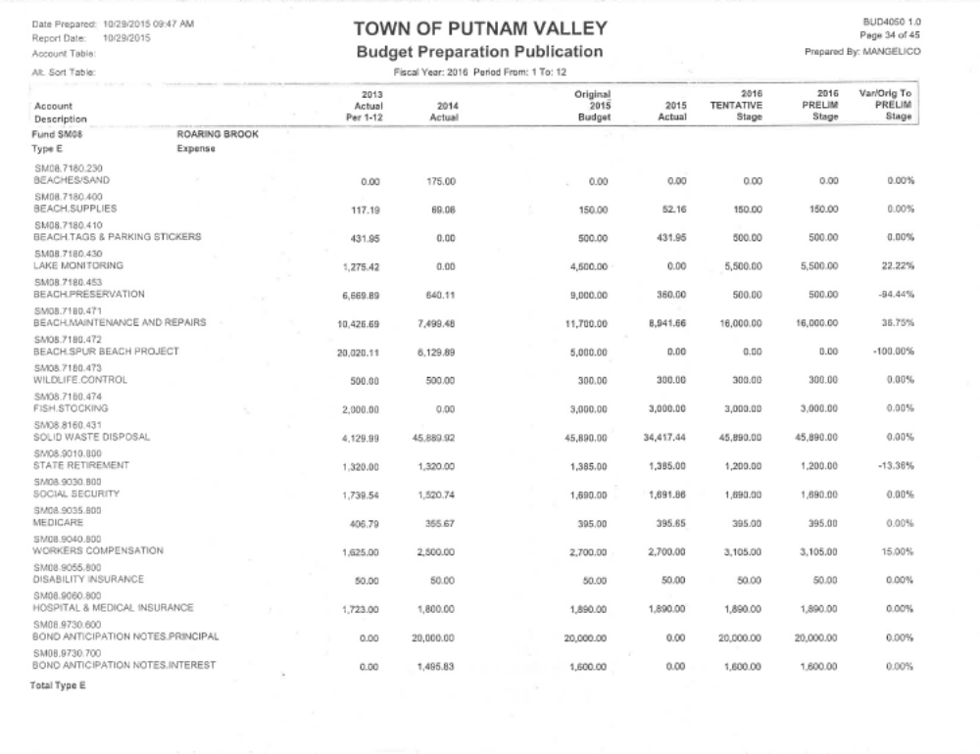

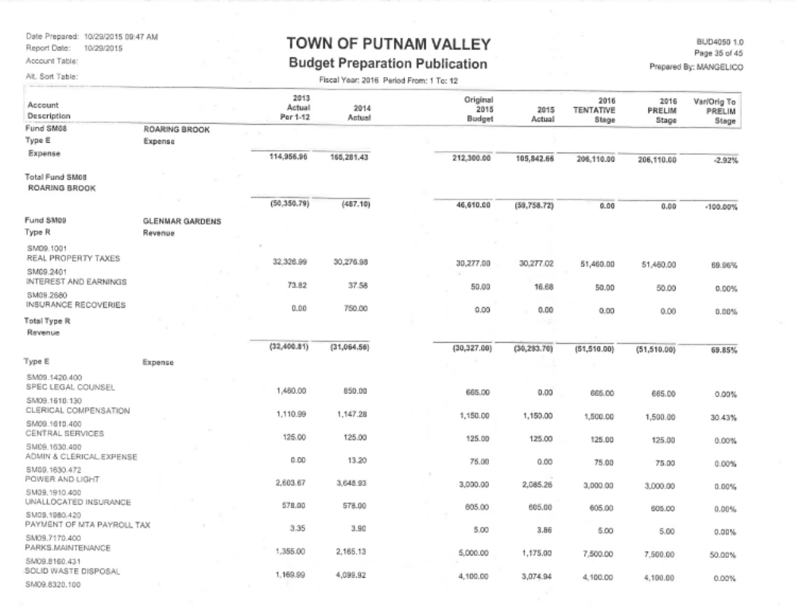
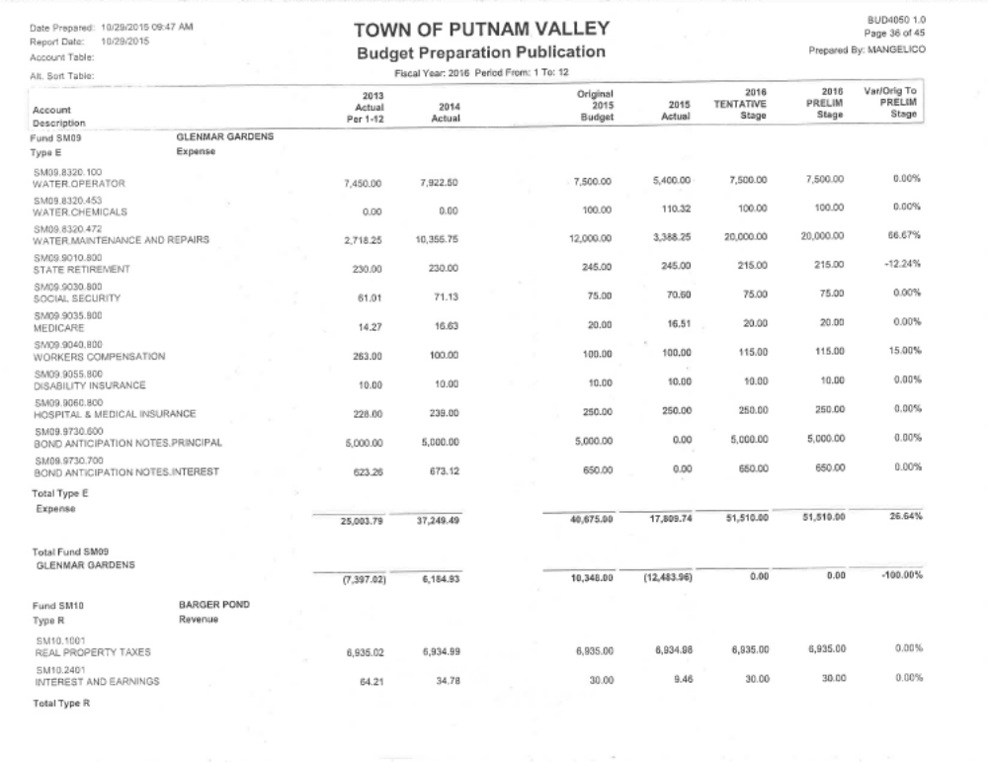
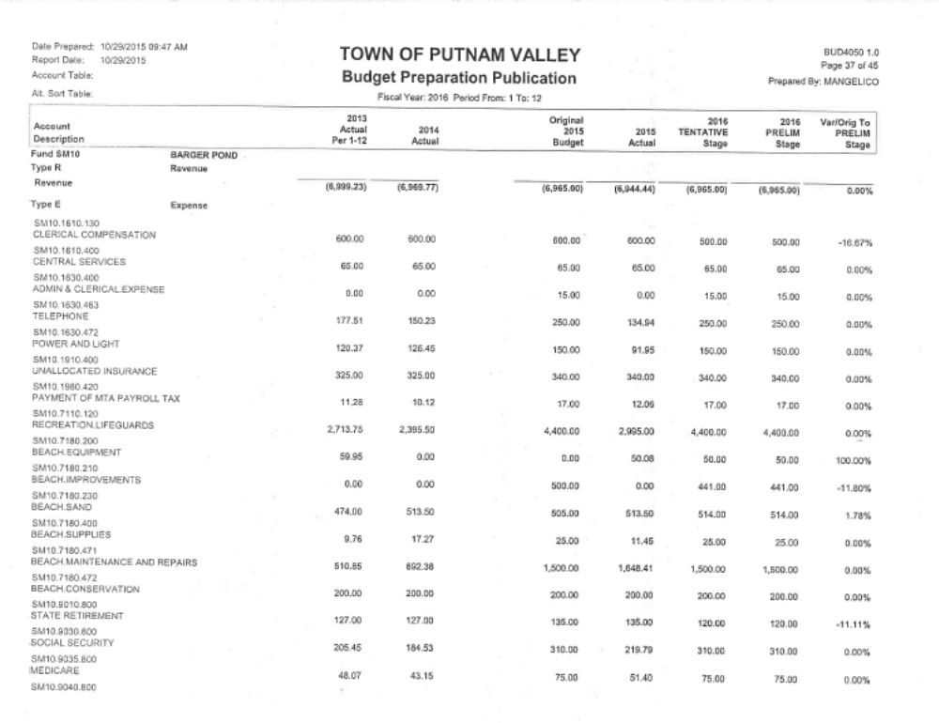
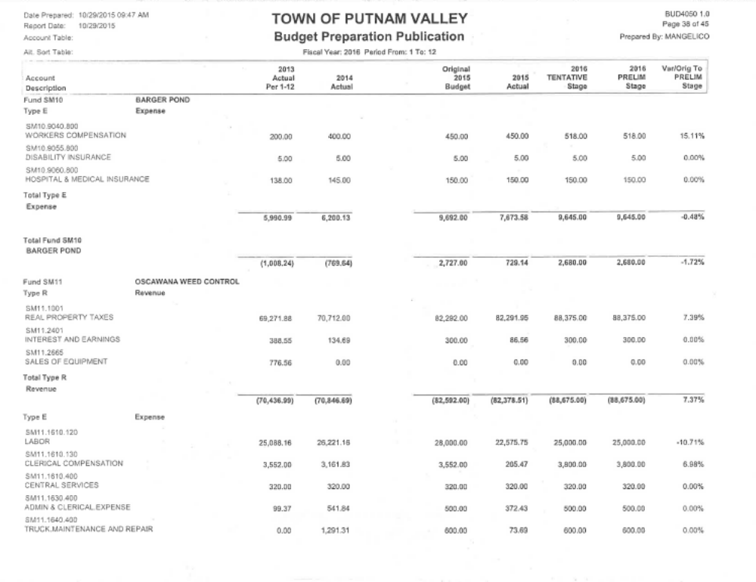
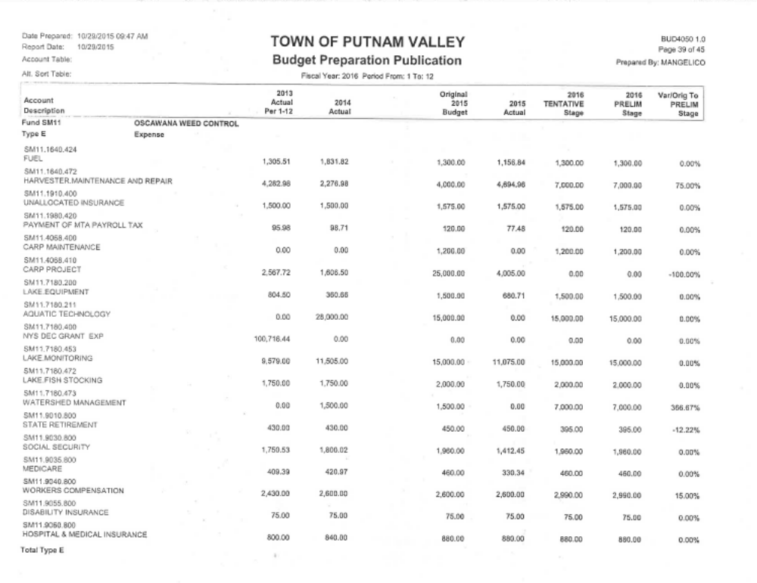

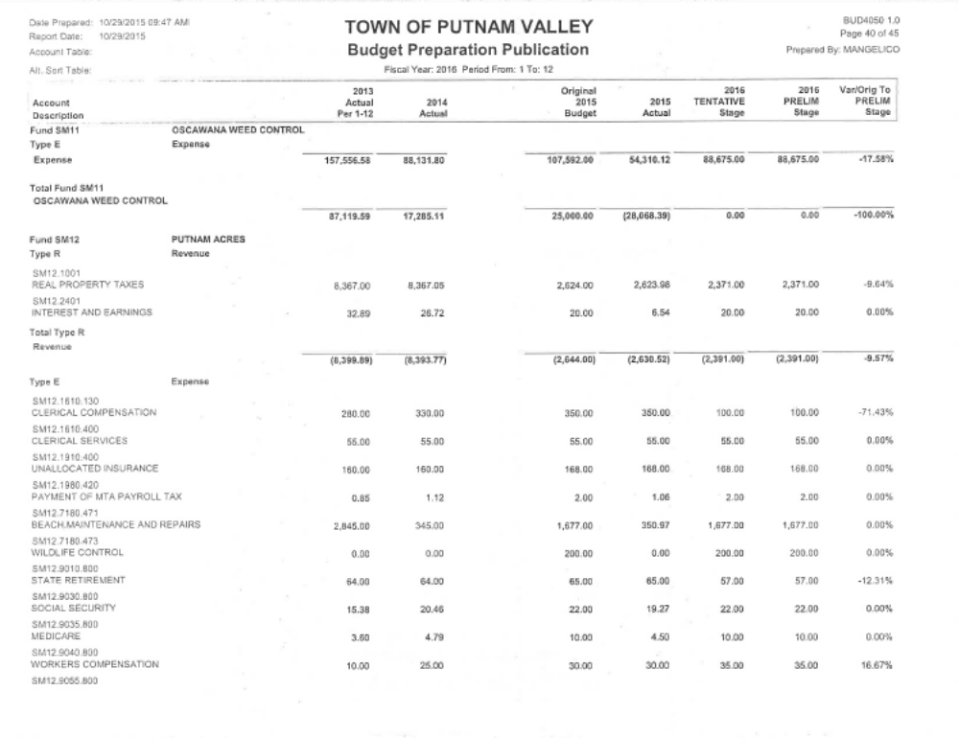
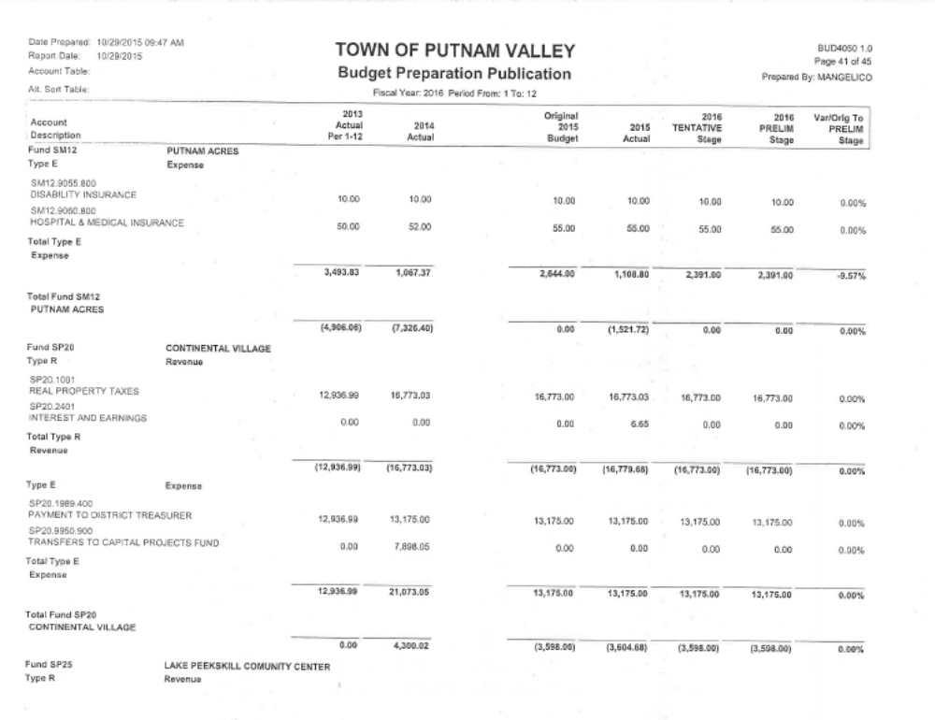
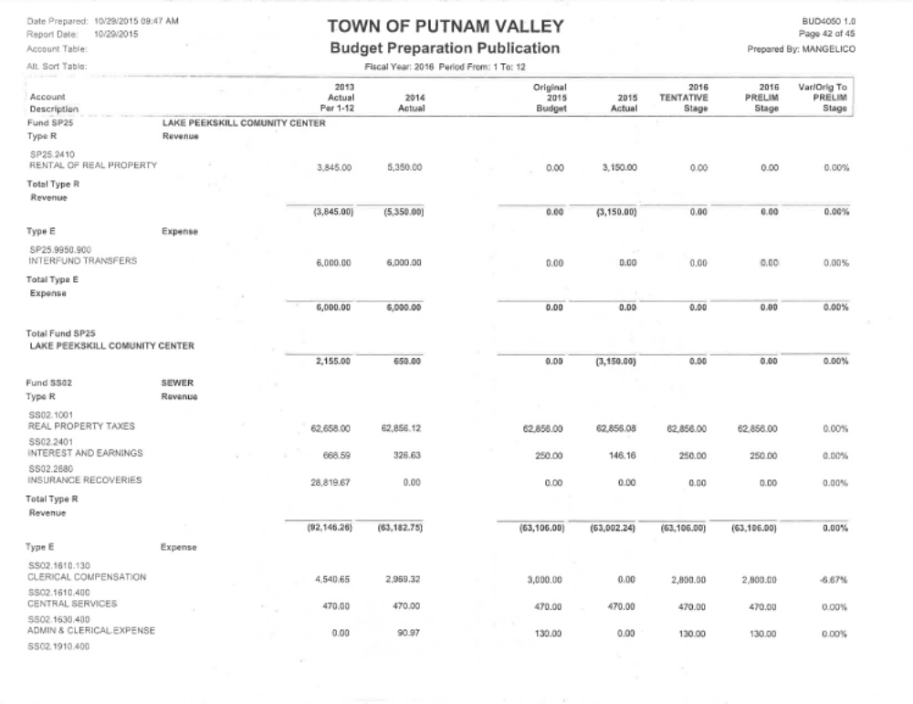
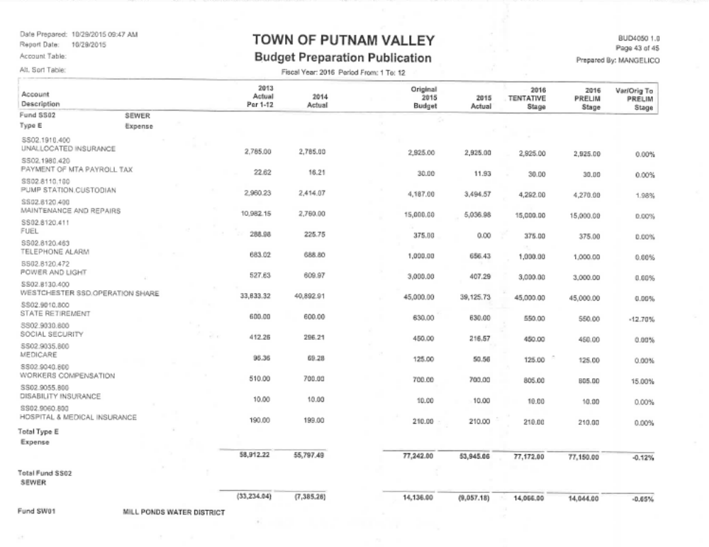
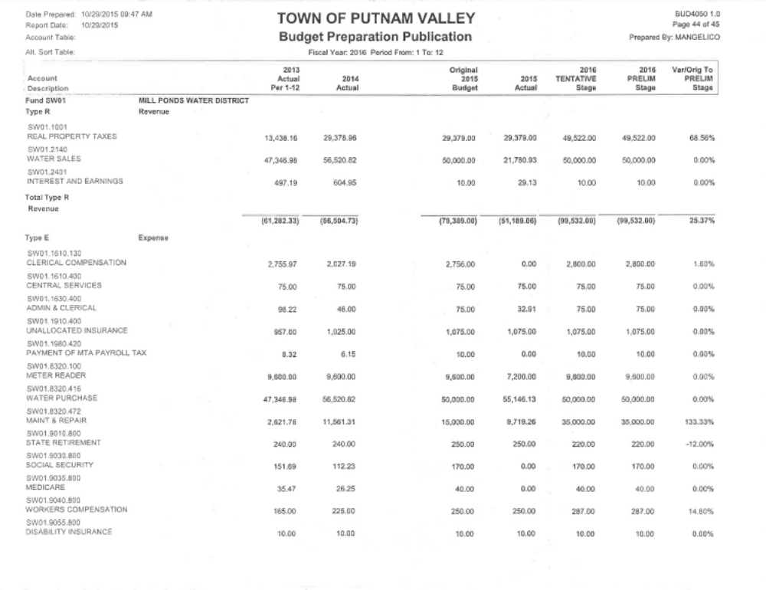

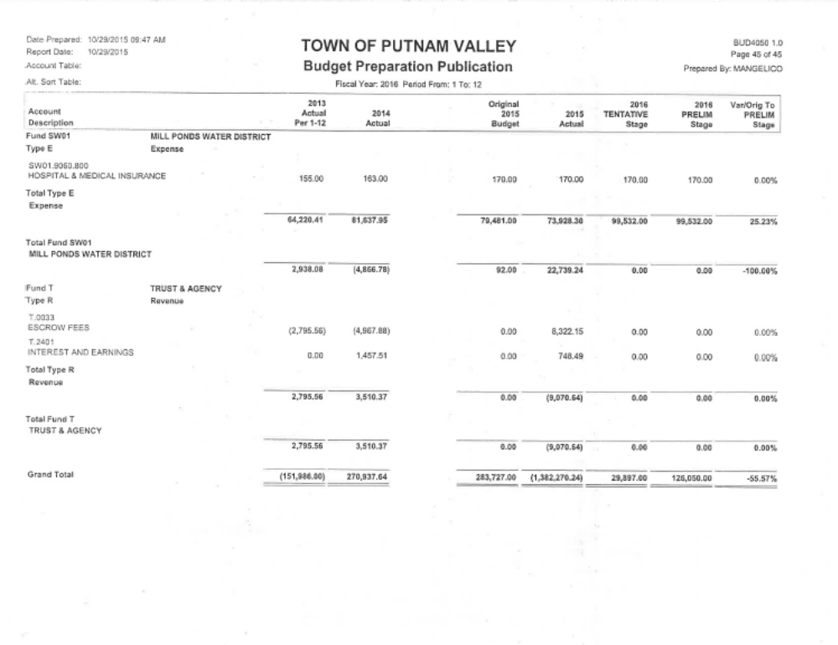

Seconded by Councilman Mackay, unanimously carried.

RESOLUTION #R15-279

RESOLVED, that the Town Board adopt the Account lines A.1001 Revenue Real Property Taxes, A.1355.110 Assessor Salary, A.4540.400 Ambulance Corps Contractual, SF01.1001 Real Property Taxes Fire Dept., SF01.3410.400 Fire Protection contractual and SF9045.800 Fire Department Service Award as part of the 2016 Town/Highway and District Budget.

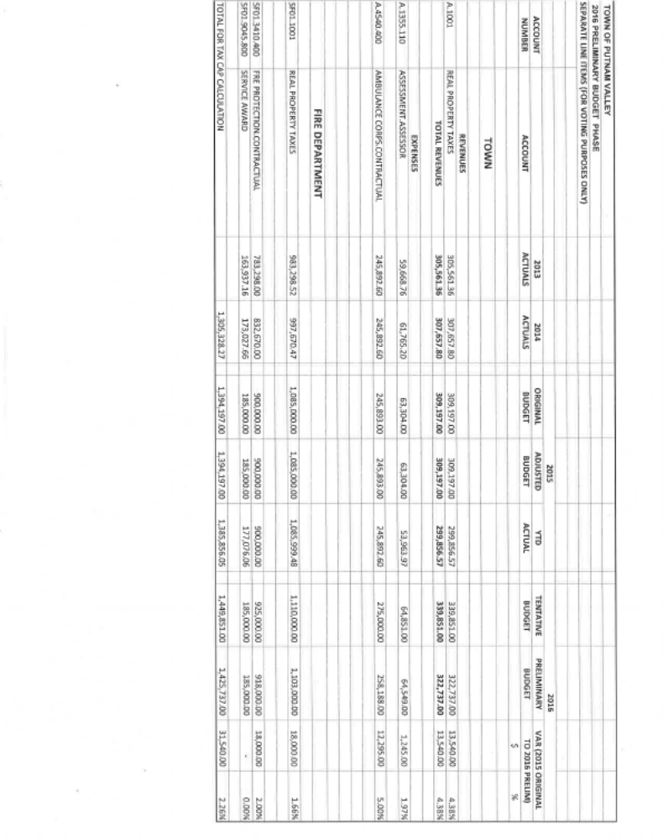
Seconded by Councilman Mackay, passed with four ayes, Councilman Luongo abstained

APPROVAL OF TOWN BOARD MINUTES
Presented by Councilwoman Annabi

RESOLUTION # R 15-280

RESOLVED, that the Town Board approve the Town Board Minutes of October 7, October 14, October 21 and October 28, 2015.

Seconded by Councilman Luongo, unanimously carried.

COUNTY LEGISLATOR REPORT

County Legislator Scuccimarra thanked the voters for their support in the recent election. If anyone has any concerns they can call her at 845-808-1020. She congratulated all that won. In regard to the Pudding Street overpass project, NYS is now planning to do it in 2020. This is not acceptable. On November 9th, the County Legislators sent a letter to New York State to get a status report on this project. The Putnam County Physical Services has obtained a federal grant to have a shuttle go from the Carmel/Mahopac area to the Croton Falls train station. If Putnam Valley residents are interested in getting a shuttle to the Garrison or Peekskill train station we need to meet and discuss, as there may be a chance that we can obtain a federal grant to do this. Putnam County is very veterans friendly, there is a program called “Return a Favor” where veterans can get discounts in local stores and restaurants. A veteran would just need to fill out a form in order to get these discounts.

Councilwoman Annabi told County Legislator Scuccimarra that she has received an update from Lisa Weiss, NYS Department of Transportation Asst. to the Regional Director in regard to the Pudding Street Overpass:

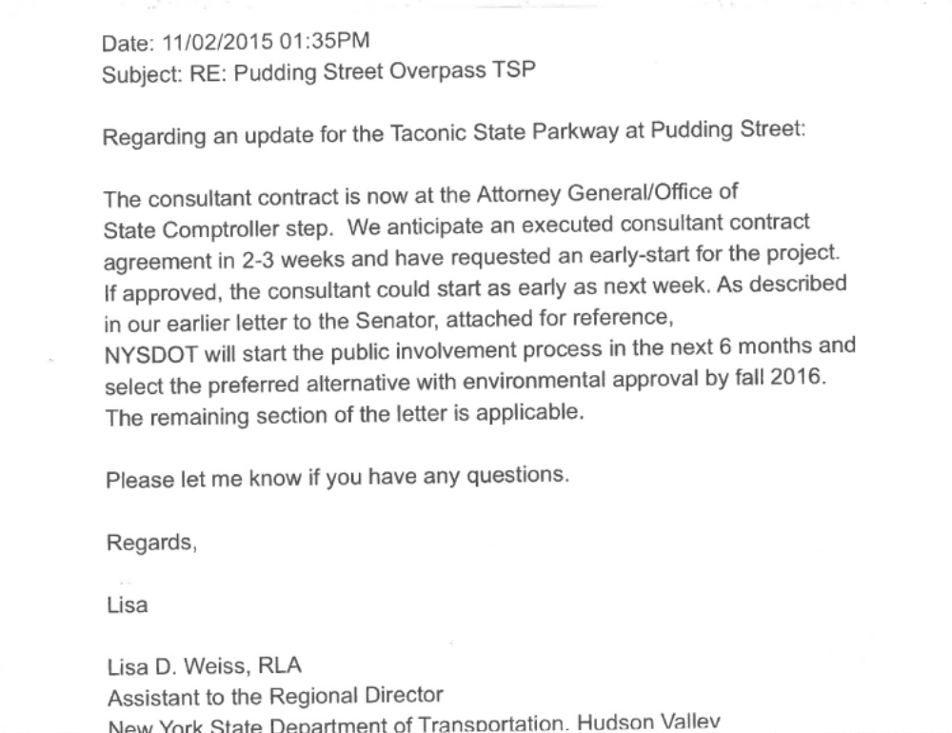

County Legislator Gouldman has stopped shaving for the month of November as it is “No Shave November”, donating the money he would have spent on shaving supplies to help people who have cancer. There will be a senior holiday luncheon at the Putnam County Golf Course, reservations required, call 845-808-1701. Putnam County is accepting applications for 2016 interns. This program gives young people hands on experience; deadline for application is January 15, 2016. The HEAP Program opened up for applications on November 16th. This program helps low income residents who have difficulty heating their homes, call Putnam County Social Services at 845-808-1500 or go to Putnam County’s website for further information. He noted to the residents that due to the recent tragedy in Paris, residents need to be aware, if you see something that’s not right, say something. If any residents have concerns please call him at 845-808-1020 or email him at William.Gouldman@putnamcounty.gov.

ACCEPT 2016 CSEA HOLIDAY SCHEDULE
Presented by Councilwoman Whetsel

RESOLUTION # R 15-281

RESOLVED, that the Town Board accept the 2016 CSEA Holiday Schedule

The CSEA Union respectfully requests the following holidays as per our contract:
January 1 | Friday | New Year's Day
January 18 | Monday | Martin Luther King Jr. Day
February 15 | Monday | President's Day
March 25 | Friday | Good Friday
May 30 | Monday | Memorial Day
July 4 | Monday | Independence Day
September 5 | Monday | Labor Day
October 10 | Monday | Columbus Day
November 11 | Friday | Veterans Day
November 24 | Thursday | Thanksgiving
November 25 | Friday | Day after Thanksgiving
December 23 | Friday | Christmas Eve
December 26 | Monday | Christmas Day
December 30 | Friday | New Year's Eve

Seconded by Supervisor Tendy, unanimously carried.

AUTHORIZE GLENMAR GARDENS WATER IMPROVEMENT BAN RENEWAL

Presented by Councilman Mackay

RESOLUTION #R15-282

RESOLVED, that the Town Board authorize the Glenmar Garden Water Improvement Bond Anticipation Note Renewal in the amount of $35,000.00 for the Glenmar Gardens Water Project. This amount represents the current balance of a 2002 note. The renewal note is 1.5% and the note will be held by PCSB Bank (formerly Putnam County Savings Bank).

Seconded by Councilman Luongo, unanimously carried.

SCHEDULE PUBLIC HEARING FOR PROPOSED LOCAL LAW-RENTAL REGISTRATION

Presented by Councilman Loungo

RESOLUTION #R15-283

RESOLVED, that the Town Board schedule the public hearing to hear public comments in regard for a proposed Local Law for “Rental Registration” for December 9, 2015 at 6:00 p.m.
Seconded by Councilman Mackay, unanimously carried.

ADOPT RESOLUTION TO PARTIALLY EXEMPT ELIGIBLE VETERANS RESIDING IN COOPERATIVE APARTMENTS FROM LOCAL TOWN TAXATION

Presented by Councilwoman Annabi

RESOLUTION #R15-284

AMEND LOCAL 2-1996 ARTICLE III VETERANS EXEMPTION
ADDING
TO PARTIALY EXEMPT ELIGIBLE VETERANS RESIDING IN COOPERATIVE APARTMENTS FROM LOCAL TOWN TAXATION

RESOLVED that the Town Board amend Local Law #2-1996 Article III Veterans Exemption adding Subdivision 8 (Veteran tenant owners of shares in cooperative apartment corporation) under Article III Section108-11 and adding F. under Section 108-12, to partially exempt eligible veterans residing in Cooperative Apartments from local town taxation.

ARTICLE III
Veterans Exemption
[Adopted 3-20-1996 by L.L. No. 2-1996]

§ 108-11. Purpose.
The purpose of this article is to maintain the ratio of the amount of the veterans exemption to the assessed valuation of the property on which the exemption was granted when the ratio may change as a result of a revaluation or update of assessment, as authorized by Subdivision 5(a) and Subdivision 8 (Veteran tenant owners of shares in cooperative apartment corporation) of § 458 of the Real Property Tax Law; to permit veterans to reapply for the exemption as authorized by Subdivision 5(b) of said § 458 of the Real Property Tax Law; and to provide for the increased alternative exemption available under Subdivision 2(d) of § 480-a of the Real Property Tax Law, as amended by Chapter 256 of the Laws of 2005.

§108-12. Adjustment of exemption amount.
- If the total assessed value of real property for which an exemption has been granted pursuant to § 458 of the Real Property Tax Law has been increased or decreased as a result of a revaluation or update of assessments in the Town of Putnam Valley, and a material change in level of assessment has been certified by the State Board of Real Property Services for the assessment roll on which such property is assessed, the Assessor shall increase or decrease the amount of such exemption by multiplying the amount of such exemption by such change in level of assessment.

- In accordance with Subdivision 5(a) of such § 458, if the Assessor receives the certification from the State Board after the final assessment roll has been filed, the Assessor shall certify the amount of the recomputed exemption to the officer having custody and control of the roll who is directed and authorized by such statute to enter the recomputed exemption on the roll.

- As an alternative to the exemption available under § 458 of the Real Property Tax Law and Subsections A and B of this section, qualifying residential real property may be exempt from taxation to the extent of 15% of the assessed value of such property; provided, however, that such exemption shall not exceed $54,000 or the product of $54,000 multiplied by the latest state equalization rate for the assessing unit or, in the case of a special assessing unit, the latest class ratio, whichever is less.

- In addition to the alternative exemption provided by Subsection C of this section, where the veteran served in a combat theater or combat zone of operations, as documented by the award of a United States Campaign Ribbon or Service Medal, qualifying residential real property shall also be exempt from taxation to the extent of 10% of the assessed value of such property; provided, however, that such additional exemption shall not exceed $36,000 or the product of $36,000 multiplied by the latest state equalization rate for the assessing unit or, in the case of a special assessing unit, the class ratio, whichever is less.

- In addition to the alternative exemptions provided by Subsections C and D of this section, where the veteran received a compensation rating from the United States Veterans Administration or from the United States Department of Defense because of a service-connected disability, qualifying residential real property shall also be exempt from taxation to the extent of the product of the assessed value of such property multiplied by 50% of the veteran’s disability rating; provided, however, that such additional exemption shall not exceed $180,000 or the product of $180,000 multiplied by the latest state equalization rate for the assessing unit or, in the case of a special assessing unit, the latest class ratio, whichever is less. For purposes of this subsection, where a person who served in the active military, naval or air service during a period of war died in service of a service-connected disability, such person shall be deemed to have been assigned a compensation rating of 100%.

- Assessment applications shall apply to all veteran tenants owning shares of stock in a cooperative apartment pursuant to the terms and conditions of §458 of the Real Property Tax Law, Subdivision 8 and as set forth herein above.

Seconded by Councilman Luongo, unanimously carried.

AUTHORIZE FACILITIES DEPARTMENT TO ADVERTISE FOR TOWN HALL MAINTENANCE POSITION

Presented by Councilwoman Whetsel

RESOLUTION # R 15-285

RESOLVED, that the Town Board authorize the Facilities Department to advertise for Town Hall Maintenance position.

Seconded by Councilman Luongo, unanimously carried.

AUTHORIZE ENGINEERING EXPENDITURE-PHOTOVOLTAIC SYSTEM

Presented by Supervisor Tendy

RESOLUTION # R 15-286

RESOLVED, that the Town Board authorize the expenditure of $680.00 to J. Robert Folchetti & Associates for review of Photovoltaic System options for the town. This expense is not covered in the grant funding. Expenditure will be covered by the Building Supplies and Maintenance Line.

Seconded by Councilwoman Whetsel, unanimously carried.

AUTHORIZE FACILITIES DEPT. TO REQUEST PROPOSALS FOR ARCHITECTURAL PLANS -TOWN HALL ADDITION

Presented by Supervisor Tendy

RESOLUTION # R 15-287

RESOLVED, that the Town Board authorize the Facilities Department to request proposals for architectural plans for a town hall addition.

Seconded by Councilwoman Whetsel, unanimously carried.

PARKS & RECREATION REFUNDS

Presented by Councilman Mackay

RESOLUTION #R15-288

RESOLVED, that the Town Board approve the following refunds:

Amy Novak $50.00
70 Mountain View Road Pavilion Rental
Putnam Valley, NY 10579 Trouble with keys

Kathryn Ferrer $1,546.40
4 Harrimac Court PVCC
Putnam Valley, NY 10579 Unable to attend

Ernest Tuitt $75.00
110 Lake Drive Basketball
Lake Peekskill, NY 10537 Now Coaching

Charles Potocki $100.00
102 Hewitt Street Basketball
Lake Peekskill, NY 10537 Now Coaching

Chris Howley $75.00
15 Fawn Run Basketball
Putnam Valley, NY 10579 Now Coaching

Joe Astrologo $100.00
118 Lockwood Road Basketball
Cortlandt Manor, NY 10567 Now Coaching

Ray Straub $100.00
124 Canopus Hollow Road Basketball
Putnam Valley, NY 10579 Now Coaching

Laura Sugantino $100.00
122 Becker Street Basketball
Lake Peekskill, NY 10579 Now Coaching

Barbra deMey $100.00
178 Sunset Hill Road Basketball
Putnam Valley, NY 10579 Now Coaching

Brian Muller $75.00
46 Stuben Road Basketball
Garrison , NY 10524 Now Coaching

Mike Marinelli $75.00
9 Blueberry Lane Basketball
Putnam Valley, NY 10579 Now Coaching

Drew Wendol $60.00
72 Floradan Road Basketball
Putnam Valley, NY 10579 Now Coaching

Nick Delfico $75.00
17 Cranberry Pond Road Basketball
Putnam Valley, NY 10579 Now Coaching

Seconded by Councilman Luongo, unanimously carried.

PARKS & RECREATION PERSONNEL

Presented by Councilman Mackay

RESOLUTION #R 15-289

RESOLVED, that the Town Board approve the following additions/changes to personnel:

Zulima Dath, PVCC Ass’t., @ $9.00 per hour

Seconded by Councilwoman Whetsel, unanimously carried.

CHILDRENS CENTER SALARIES-PARKS & RECREATION

Presented by Councilman Mackay

RESOLUTION #R15-290

RESOLVED, that the Town Board approve the following salary increases:
Toniann Cortina Child Care Assistant II $16.20
Vicky McDonald Child Care Assistant II $16.70
Patricia Barone Child Care Assistant I $10.58
Sue Bunting Child Care Assistant I $10.83
Patricia Citarella Child Care Assistant I $14.66
Toniann Cortina Child Care Assistant I $13.20
Marilyn DeNisco Child Care Assistant I $14.30
Brian Fitzmaurice Child Care Assistant I $10.45
Rich Karlson Child Care Assistant I $15.70
Tyler Kroll Child Care Assistant I $9.45
Justin Kroll Child Care Assistant I $9.45
Ryan Lopez Child Care Assistant I $9.45
Deborah Montaruli Child Care Assistant I $14.02
Michael Rufo Child Care Assistant I $10.45
Andrew Salustri Child Care Assistant I $11.55
Wendy Staffieri Child Care Assistant I $10.20
Kristen Tyra Child Care Assistant I $9.45
Jessica Viveros Child Care Assistant I $9.45
Melissa Wagner Child Care Assistant I $9.56
Amanda Yanarelli Child Care Assistant I $10.20

Seconded by Councilwoman Whetsel, unanimously carried.

BUILDING DEPARTMENT REPORT

Presented by Councilwoman Whetsel

RESOLUTION #R15-291

RESOLVED, that the Town Board accept the Building Department report for the month of October 2015, for filing with the Town Clerk.

Seconded by Councilman Mackay, unanimously carried.

APPOINT SNOW PLOW RIDERS

Presented by Councilwoman Whetsel

RESOLUTION # R15-292

RESOLVED that the Town Board appoint the following as snowplow riders for the year 2015-2016 at the rate of $11.44 per hour with no benefits:

ANDERSON, DAVID III | HERRMAN, LUKE
ANDERSON, JAKE | HERTELENDY, JOE JR
ANGSTADT, BRIAN | HOHLOCH, ANDRE
BACKUS, ANDREW | JONES, TYLER
BACKUS, MARK | LUTZ, CHRIS
BROWN, ZACK | LUTZ, JIMMY
CATRINI, BILL | OGRADY, ANDREW
COBB, JASON | POWDERLY, KEVIN
COBB, LARRY JR | ROBINSON, FRANK
FARONE, MATTHEW | ROHRAUER, KENNETH
FARONE, THOMAS | RONDON, JOVAN
GAMBECKI, TRAVIS | SCHARFF, BRIAN
GRIECO, JOE | SCHULZ, JONATHAN
HEADY, ZACHARY | WILLIAMSON, MICHAEL
HERNANDEZ, ROBERTO | FEJES, THOMAS

Seconded by Councilman Mackay, unanimously carried.

LAKE PEEKSKILL DISTRICT REPORT

Councilwoman Annabi has good news for Lake Peekskill. The plaque is missing at the Lake Peekskill memorial, honoring those we lost in WWII. Sally Sypher found a newspaper article dated August 1942 that had the list of WWII fallen soldiers. We are going to compare the photograph and the list to see if it is the same, if it matches we will order a new plaque.

ACCEPT WILDWOOD KNOLLS REVENUE REPORT

Presented by Councilwoman Annabi

RESOLUTION # R15-293

RESOLVED that the Town Board accept the 2015 Wildwood Knolls Revenue Report, 12 families @ $100 per family-$1200. Original Warrant presented was for $1900, seven families chose not to use facility in 2015.

Seconded by Supervisor Tendy, unanimously carried.

AWARD BID FOR SPUR BEACH SLOPE CORRECTION

Presented by Councilwoman Annabi

RESOLUTION # R15-294

RESOLVED that the Town Board award the bid to Tompkins Landscaping Corp., P.O. Box 507, Shrub Oak, NY 10588 for the Spur Beach slope correction project at the total cost of $26,740.00.

Seconded by Councilman Mackay, unanimously carried.

PUBLIC COMMENT

John Cohen, member of the Tompkins Corner Cultural Center told the residents that the Harvest Festival was wonderful. There were lots of music and performances by the residents in Putnam Valley. He also noted that the Putnam Valley High School Music Club will be performing at the Tompkins Corner Cultural Center on November 24th at 7:00 p.m. This is wonderful that the school and the cultural center can come together and perform for our residents.

BUDGET TRANSFERS AND AMENDMENTS

Presented by Supervisor Tendy

RESOLUTION #R 15-295

RESOLVED, that the Town Board approve the following budget transfers and amendments as submitted by bookkeeper Maria Angelico:

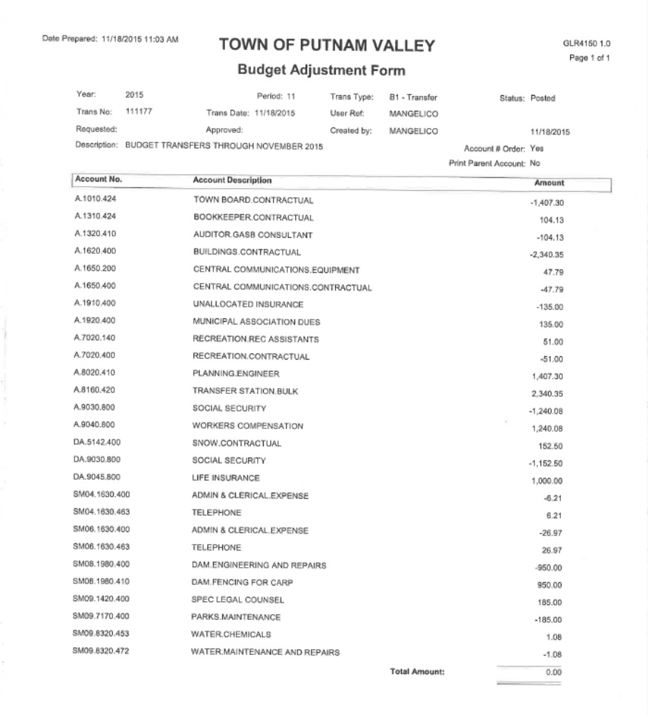

Seconded by Councilwoman Annabi, unanimously carried.

AUDIT OF MONTHLY BILLS

Presented by Supervisor Tendy

RESOLUTION # R 15-296

RESOLVED, that the Town Board approve the following bills after audit, being paid:

VOUCHER NUMBERS AMOUNTS
13428-13455; 13478-13497 $61,100.08
13589-13591; 13597-13616;
13633-13658; 13670-13685 $62,510.73
13403-13407; 13499-13507;
13525-13560; 13532; 13536-
13537; 13539-13540; 13542-
13546; 13548; 13550; 13578-
13588; 13592-13596; 13632 $81,015.83
13531; 13533-13535; 13538;
13541; 13547; 13549; 13551-
13577; 13659-13669; 13693-
13697 $47,799.82

Seconded by Councilwoman Annabi, unanimously carried.

Supervisor Tendy moved to go into Executive Session at 8:25 p.m. to discuss personnel matters and possible litigation with no further business taking place.

Respectfully submitted,

Eileen Royael
Town Clerk 11-23-15

